**­­­University of California, Irvine**

**Study Design and Procedures**

**Cross-Linguistic Adjective Ordering Preferences Survey**

**Lead Researcher**

Suttera Samonte

Department of Cognitive Sciences

Email: [ssamonte@uci.edu](mailto:ssamonte@uci.edu)

**Faculty Advisor/Co-Researcher**

Dr. Gregory Scontras

Department of Linguistics

Email: [gsconttra@uci.edu](mailto:gsconttra@uci.edu)

**Setting and Mode:** We will be asking participants for their intuitions about adjective phrases. The survey will be administered to adults via the internet (e.g. email, Facebook).

**Approximate Duration:** The experiment will take approximately 10 minutes to complete.

**The following outlines the procedures of the survey:**

1. Participants will see the study information sheet on their web browser, and if they decide to continue, will proceed with the survey as described below. All text will appear in both English and Tagalog translations.
2. Participants will see an instruction slide next, which briefly explains the survey. The instruction slide will contain information as follows:

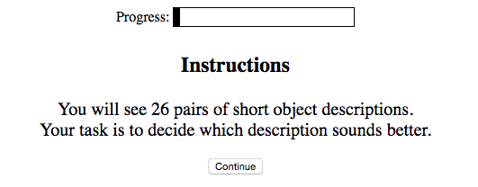

1. Participants will then be presented with an adjective-noun phrase and asked to slide a bar at the bottom of the page indicating how natural they find that word order, as in this example:

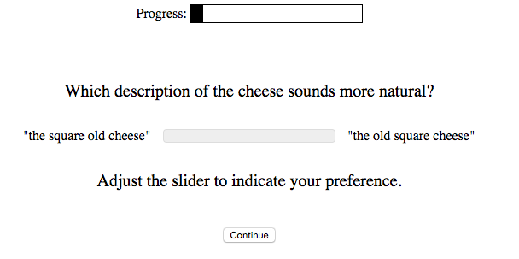

1. After all the trials, participants will be asked to complete a voluntary participant information page. No personally-identifying information will be gathered. They will be asked about their gender, age, native-language proficiency, what language(s) were learned first, level of education, enjoyment of the HIT, meta-awareness of the researchers’ hypothesis, and any additional comments they have about the experiment.